Download PostgreSQL Installer for Windows

You need to download the installer from PostgreSQL Official website.

* Go to the PostgreSQL official website, download section for Windows <http://www.postgresql.org/download/windows/>
* Click on the [download installer from EnterpriseDB](http://www.enterprisedb.com/products/pgdownload.do#windows)
* Choose the latest version to download. It takes few minutes to complete the download.

Install PostgreSQL step by step

Double click on the installer file, an installation wizard will appear and guide you through multiple steps where you can choose different options that you would like to have in PostgreSQL.

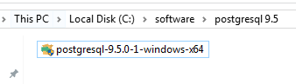

The following illustrates each step and its options for installation. If you install a different version, you may get additional steps.

Start Installing PostgreSQL

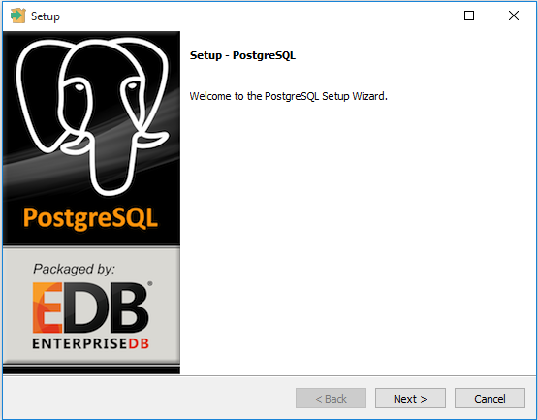

Specify installation folder, choose your own or keep the default folder suggested by PostgreSQL installer.

Enter the password for the database superuser and service account.

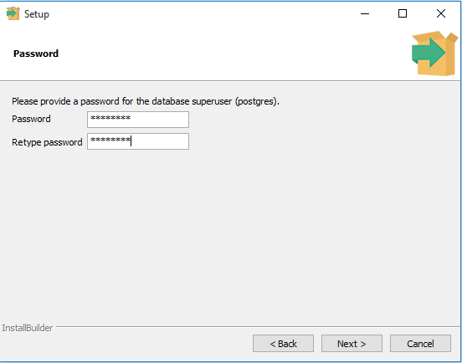

Enter the port for PostgreSQL. Make sure that no other applications are using this port. Leave it as default if you are unsure.

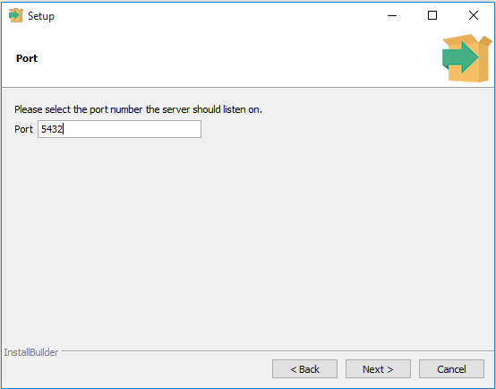

Choose the default locale used by the database.

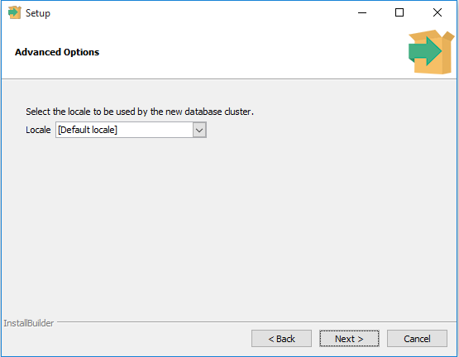

You’ve completed providing information for the PostgreSQL installer. Click the Next button to install PostgreSQL

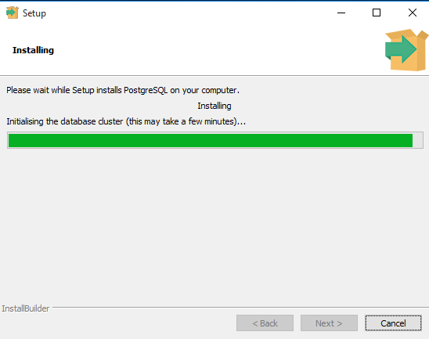

The installation may take few minutes to complete.

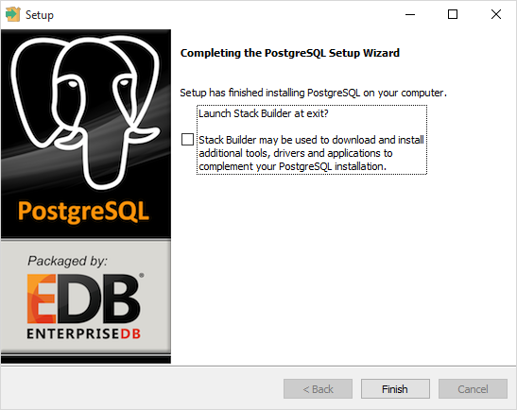

Click the Finish button to complete the PostgreSQL installation.

Verify the Installation

There are several ways to verify the installation. You can try to [connect to the PostgreSQL](http://www.postgresqltutorial.com/connect-to-postgresql-database/) database server from any client application e.g., psql, pgAdmin, etc.

The quick way to verify the installation is through the pgAdmin application.

First, click on pgAdmin III to launch it. The pgAdmin III GUI will display.

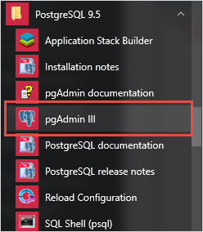

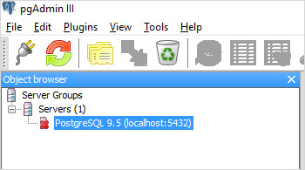

Second, double click on**PostgreSQL 9.5** on the object browser. It will ask you for the admin password. Just enter the password you’ve used in the installation step.

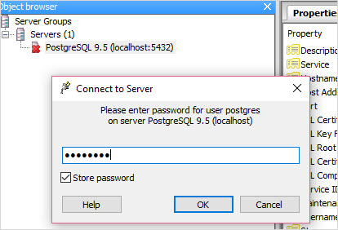

Third, if everything is fine, the pgAdmin will display all the objects that belong to the server.

